KASB-E-HALAL) (LAWFUL EARNING)

**Meaning of Kasb-e-Halal:**

Kasb-e-Halal means lawful, legal and Riba free earning.

**Definition of Kasb-e-Halal:**

It is defined as all provisions and earnings that are Riba free, legal and lawful under the legitimation and having religious acceptance. It is also refers to the earnings which are according to the economic principles of Islam.

**Significance of Kasb-e-Halal**:

Kasb-e-Halal has a significant value in social, moral and economical system of Islam. Lawful business has been termed as blessing of Allah Almighty. He loves and likes those people who follow the rules and regulations regarding the lawful earning and as mentioned in the Holy Quran and Sunnah. All business employments must be based on lawful earnings. In the light of Holy Quran and Hadith, lawful earning is halal (lawful) and unlawful earning is haram (unlawful). All rules, regarding, general perception and special perception about lawful earning have been mentioned clearly in the Holy Quran.

**Kasb-e-Halal and the Holy Quran:**

Allah Almighty says about lawful earnings:

“(Saying) eat of the Tayyib (good lawful things) we have provided you, and commit no transgression or oppression therin, lest my anger descends, he is indeed perished.”

**Explanation:**

In this verse the basic principle about lawful earnings has been described; it is said that eat only pure things which Allah Almighty has provided you and do not exceed the limit, the Arabic word “Tagha” is used and its meaning is “to exceed and cross the limitation” i.e. eat lawful, bad and impure things. The result of disobedience of Allah Almighty is thanklessness on His bounties. Those people who cross the limitations and eat

Unlawful and impure things, they get great anger of Allah. The Holy Prophet Muhammad said that “lawful earning is obligatory like other obligatory things for every believer”. Islamic teachings warns the person who gets/ eats unlawful earning, his worship will never be accepted. Although the verse no 81 of Taha is about the Ummah of Prophet Musa but it also gives the lesson to the followers of the Holy Prophet Muhammad.

Practical Link:

Allah Almighty doesn’t like unlawful things for the true believers. We should not earn/eat unlawful things in our daily lives. We must choose only lawful means of earnings in our practical lives.

**THREE PRINCIPLES OF KASB-E-HALAL:**

Moral Values, Business and Religion:

Moral values, business and religion are deeply linked with each other. The Holy Quran indicates that business and economics are “Fazrullah” and it means bounty, favor and blessings.

Positive Struggle for Lawful Earnings:

Islam prepares his followers to do hard work and struggle for lawful earnings. It dislikes struggles less, effortless, unemployment and begging.

**Difference between Lawful and Unlawful:**

Islam stresses about legal earnings and forbids illegal earnings. Every profit and earning that will be earned/received through unlawful and illegal sources will be put in Hell (fire). The entire process of earnings should be fair and transparent.

**THREE IMPORTANT INSTRUCTIONS OF THE HOLY QURAN ABOUT LAW EARNINGS:**

These are as under:

**Common and Universal Message:**

Allah Almighty says:

“O, mankind! Eat of that which is lawful and good on the earth, and follow not the footsteps of Shaitan (Satan). Verily, he is to you an open enemy.”

Special Message for Believers:

Allah Almighty says:

“O you who believe (in Oneness of Allah – Islamic Monotheism) Eat of lawful things which we have provided you with, and be grateful to Allah, if it is indeed He whom you worship.”

Special Message for Prophets:

Allah Almighty says:

“O (you) Messengers! Eat of the Tayyibat [all kinds of Halal foods which Allah has made lawful (meat of slaughtered eatable animals, milk products, fats, vegetables, fruits, etc.] and do righteous

deeds. Verily I am all knower what you do.

**SAYINGS OF HOLY PROPHET MUHAMMAD REGARDING LAWFUL EARNINGS:**

Two sayings of the Holy Prophet are as under:

**BUKHARI AND MUSLIM:**

Lawful and unlawful things are clearly mentioned however, there are doubtful things between the both and most the people have no knowledge of these. Any person who saved himself from these doubtful things, he will save his Deen (Faith & Religion) and his honor and anyone who fails in these doubtful things he will commit unlawful (sin). Like a grazer who grazes his animals near a protected grazing ground and his animals may enter it. Know that every king has its protected grazing ground and the protected ground of Allah Almighty are His Hudood (limitation. Verily there is a bit of flash in human body, if it is right the entire body remains right and whem it becomes corrupt, all the body becomes corrupt. Know it is the heart. (Bukhari and Muslim).

The Holy Prophet Muhammad Said:

Allah Almighty is pure and the excellent (to His as His glory and majesty) and does not accept pure. He ordained the believers of that for what he ordained his messengers, so he said to his prophets, to eat from pure (lawful) things and do good deeds. Similarly he ordered the believers, to eat from pure things which I have provided you. Then the messenger of Allah, Muhammad narrated a story of a man who travels a long journey, and his clothes and body becomes dusty. He raises his hands towards sky seeking Allah’s blessings and says O my sustainer, but his food, his drinking and his clothes consist of Haram (unlawful). So his prayer will never be accepted. (Muslim).

**Explanation :**

The first saying of the Holy Prophet, Muhammad indicates that lawful and unlawful things are very quite clear so we should accept lawful things and reject unlawful. The third thing is doubtful that is between the both which must be avoided as far as possible. Our beloved Prophet Muhammad explained it with fine example that do not go near the protected grazing and always keep your selves towards right and correct direction of your intention and heart. We must follow these instructions in our practical lives.

The second saying of the Holy Prophet gives the lesson that Allah is pure and accepts pure things only. In this

Hadith, Our Beloved Prophet Muhammad has mentioned a fruitful story that if any person, who earns unlawful foods, drinks and clothes, his invocation (Doa) will never be granted/accepted. We must be very careful, in our practical lives about Kasb-e-Halal.

Lawful Earning in the Light of Holy Quran: (Surah Al-Araf verse # 32 and Surah Al-Baqarah verse no 188), Islam tells us certain lawful principles which are to be taken as the standard. All future decisions would be based on this. Allah Almighty tells us that what was incorrect in our past and what would be correct in future. Allah says:

Say O Muhammad : “Who has forbidden the adornment with clothes given by Allah, which He has produced for His slaves, and At-Taiyyibat [all kinds of Halal (lawful) things] of food? Say: “they are in the life this world, for those who believe, (and) exclusively for them (believers) on the Day of Resurrection (the disbelievers will not share them).” Thus we explain the ayaat (Islamic laws) in details for a people who explain knowledge.

In Surah Al-Baqarah, verse # 188, Allah Almighty gives the messages that do not usurp the properties of each other by deception. If a person lays is claims on a some else’s property will out my regular proof and successes in his attempt, his act will be consider unlawful such a person is the criminal in the sight of Allah.

**AYAT-E-MUBARAK**

**SURAH E BAQARAH**

**VERSE NO.188**

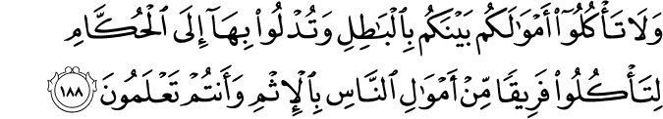

**Translation**

And do not eat up your property among yourself for vanities,nor use it as bait for the judges,with intent that ye may eat up wrongfully and knowingly a little of (other) people’s property.

**Explanation**

The purpose of fast is not completed until this fourth greed is also restrained. Ordinarily honest men are content as they refrain from robbery, theft, emblements etc. etc. Two more subtle forms of greed are mentioned here. One is where one uses one’s property for corrupting others, judges or those in authority so as to obtain some material gain even under the cover and protection of the law. The word translated The people property” may not mean public property. A still mote subtle form is where we use our own property ‘property under our control, among ourselves vain or - frivolous purposes. According to Islamic standard this is also Property carries with it its own responsibilities. If fail to understand or fulfil then we have not learnt the full lesson of self-denial from Saum (fast) among bait for eat up (others) no harm but on the contrary care in all humility. When Almighty Allah withdrew His favour from Israel, because of their sins, and bestowed it on another nation, the jealously of Israel plunged deeper into sin. To kill or seek to kill an individual because he represents an ideal is to kill all who uphold the ideal. On the other hand, to save an individual life in the same circurnstances is to save the whole community. could there be a stronger condemnation ‘M individual assassination, and revenge than this?

Even if someone wished to ‘kill him, a Muslim should not consider it his or her right to kill that person.

Every time a Muslim kills an animal for food, it should be done by the halal method, with prayer. As regards the killing of men this is always thought to be wrong with certain very limited exceptions. ‘Mercy” killing is not allowed, and neither is the convenient disposal of sick or old people.

Killing on the battlefield can only be condoned under certain conditions, the chief of which is that the war is defensive to protect, the honour of Almighty Allah of His people (in the widest s and in whatever country they belong).. Killing as legal execution is also only; condoned under certain very strict conditions.

**SURAH E AL-A’RAF**

**VERSE NO.32**

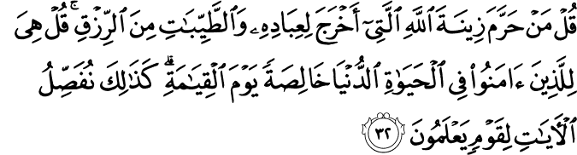

**Translation**

Say: Who hath forbidden the beautiful(gifts) of Allah, which he hath produced for His servants, and the things, clean and pure,(which He hath provided) for substance? Say: They are, in the life of this world, for those who believe ,(and) purely for them on the day of Judgment. Thus do We explain the signs in detail for those who understand.

**Explanation**

The verse # 32 of Surah Al-Araf indicates that the faith of a true believer in Allah Almighty must be unshaken. We should obey His orders and instructions only because he has provided us every thing. No one has the authority deprive us from the things that Allah

Almighty has declared lawful for us. The legal and lawful things are created by Allah Almighty for believers in world and non believers are also benefiting from them in this world. But on the Dooms Day all blessings, provisions and good things are only for the believers.

**Explanation:**

The beautiful and good things of life are really meant for, and should be the privilege of those with faith in Almighty Allah. If they do not always have them in this life, and if there is sometimes the semblance of others having them who do not, deserve them, it may be due to lack of our understanding. Our faith in Allah’s wisdom should be unshaken. Their pure counterparts in the spiritual world will be only for those who proved, in all the trials of this world, that they had faith.

In many cases the matter is that of behaviour. These are divided into five major categories:

**1 Farz or Wajib**: Things which are compulsory for the Muslims and

must be done.

2. **Hararm**: Things which are forbidden and must never be done; for. example telling lie for immediate ‘material benefit, measuring less against the l charge, earning through betting or eating up the properties of others.

3.  **Mandub**: Recommended actions, for example giving of unselfish hospitality, generous compassion, truthfulness, justice

4. **Makruh**: Actions not forbidden, but disapproved.

5. **Mubah**: Actions to be decided by one’s own conscience, because there is no clear guidance.

SURAH E AL-A’RAF

VERSE NO.33

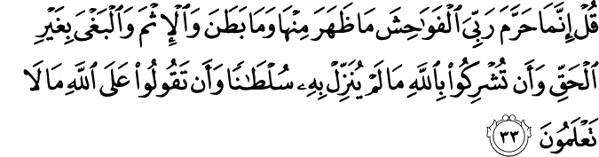

Translation

Say: the things that my Lord hath indeed forbidden are: shameful deeds, whether open or secret; sins and trespasses against truth or reason; assigning of partners to allah ,for which He hath given no authority; and saying things about Allah of which ye have no knowledge.

SURAH E AL-TA’HA

VERSE NO.81

Translation

(Saying): “Eat of the good things We have provided for your sustenance, but commit no excess therein, lest My Wrath should justly descend on you: and those on whom descends My Wrath do perish indeed!

SURAT TAUBA VERSE NO 34:

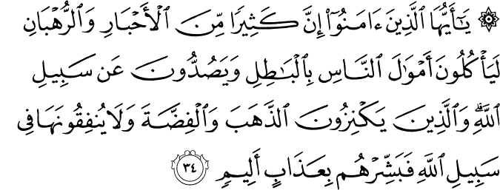

TRANSLATION:

you who have believed, indeed many of the scholars and the O monks devour the wealth of people unjustly and avert [them] from the way of Allah . And those who hoard gold and silver and spend it not in the way of Allah - give them tidings of a painful punishment.

(‘Surah Al-Tauba: 34)

Almighty Allah has declared many things as handiwork of Satan “and He warns the believers to leave them aside as they are not permissible, rather they ‘breed hundred of evils, Almighty Allah addresses the believers:

“0 ye who believe! Strong drink and games of chance and idols and divining arrows are only.

Explanation:

Before the advent of Islam many of the tribes had allowed, or forbidden, use of many things, actions and behaviours according to their God-less beliefs and whims. There were many opinions as to what things or sorts of behaviour were haram or halal (Both these words were used before Islam). Some religious people were highly fanatic and extremist in their outlook forbidding all sorts of foods, normal sexual behaviour in marriage, and so forth. On the other hand, others considered certain barbaric and uncouth behaviour to be perfectly permissible things, like cruelty to women and slaves, sexual license, drunkenness, bungling in trade, fraud in earning livelihood, fleecing the people, favoritism and corruption etc. Islam established certain legal principles, which were to become the criteria on which all future decisions would be based. Allah points out what was wrong in the past and what would be right in future.

(Khutba Hajjat-ul-Wida)

Kasb-i-HalaI, according to Islam is what we earn earnestly and honestly and by our own effort and labour, in accordance with the set economic principles of Islam. Riba (Interest) is completely prohibited. The Prophet (p.b.u.h.) says:

“VeriLy, all Riba of (the days of) forbidden: you shall only have your money, wrong not, nor ye be the Riba of (my uncle) Abbas, cancelled.” (Khutba Hajj- at-ul- Wida) not forbidden, but ignorance is the capital of wronged, and all of it, is cancelled”.

**Reported by Hazrat Jabir)**

Hazrat Abu-Hurarrah has reported that the Holy Prophet (p.b.u.h.) said:

“Avoid you the seven destructive things: the joining (of others) with Allah. the killing of breathing things which are forbidden unless by right. the devouring of Riba, devoting the wealth of the orphan, turning (one 4 back on the day of battle, and calumniating chaste women who are beliveving (but) careless (in their behaviour).

**SAHI MUSLIM:**

In another Hadith narrated by Hazrat Abu Hurarrah:

‘The messenger of Allah said: verily Allah is the good (to him be glory) and does not accept (or receive) save good, and Allah ordains the believers what Lie has ordained the Messengers (p.h.u.h.) so He said: 0 Apostles eat of the good things and do righteous, deeds, He, the Exalted, said: 0 believers eat good (lungs where We have provided you. Then the Messenger (p.b.u.h.) mentioned (a story the man who often travels and remains unkempt and dusty, He stretches his hands to heaven, (‘by saying) Sustainer 0 my Sustainer, while his food his drinking, dress (‘all of them) are illegitimate (haram).How could his prover be granted “.

JAMAH TIRMIZI:

The following Hadith is narrated by Hazrat lbn i—Masud (Tirmizi).

The Holy Prophet (p.b.u.h.) said:

“When the children of Israel fell into sins their learned men forbade them, but they desisted not. Then (her sat in their meetings, and ate and drank with them; then Allah struck (their) hearts, one of them upon another; and cursed them through the tongue of Hazrat Daud and Hazrat Isa,. son of Mary (p. b. u. h that was to) that they rebelled and were transgressors.

(‘Sahih Bukhari)

**Reported by Hazrat Anas (‘Sahih Bukhari)**

The greed of a man for wealth has also been out rightly condemned by the Prophet (p.b.u.h.). 1 says:

‘No hungry wolves sent into a herd of sheep have wrought more ruin than (lie greed of a man for wealth anti dignity to Ins religion

(Reported by Ka ‘ab Bin Malik (Jamah Tirmizi)